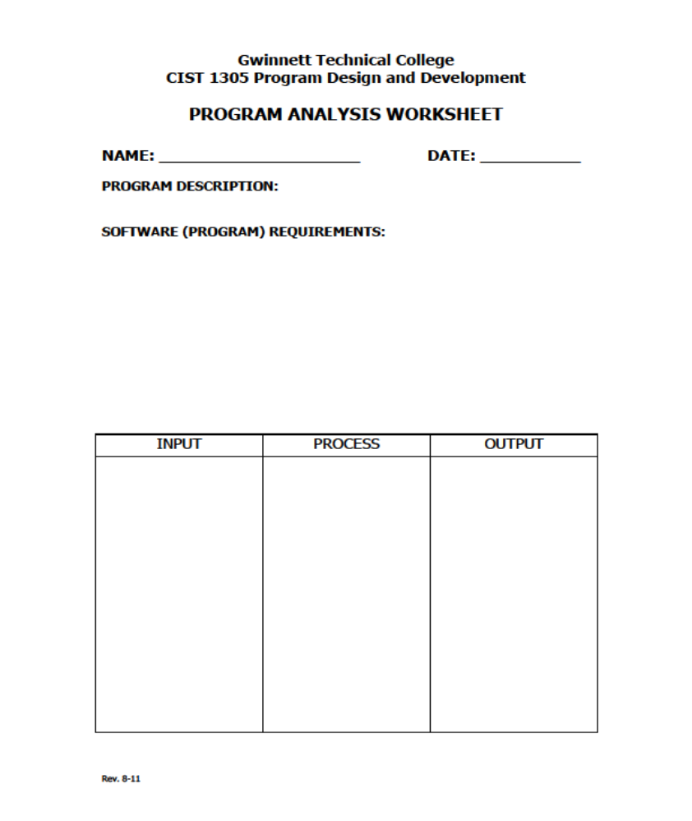
Jacob Williams

Membership Fee
Increase the membership fee (2,500) by 4% for the next 6 years
Year

current_charge * (1 + Year * rate)

YrRate

